**Report 3**

**Progress Made:**

1. Food and Beverages page is made which contains different categories of foods and beverages made in India and in Foreign countries. It includes 5 categories:
   1. Soft Drinks
   2. Snacks
   3. Ice creams
   4. Biscuits
   5. Chocolates
2. All the added sections are responsive.

**Technologies used:**

HTML 5

CSS 3

Bootstrap v4.0

JavaScript for using Bootstrap features

**Fonts used:**

These font families are taken from Google fonts

For logo: Font family used is ‘Merienda One’.

For ‘Food and Beverages’ heading: Font family used is ‘Righteous’.

**Snapshot of Foods and Beverages Page**

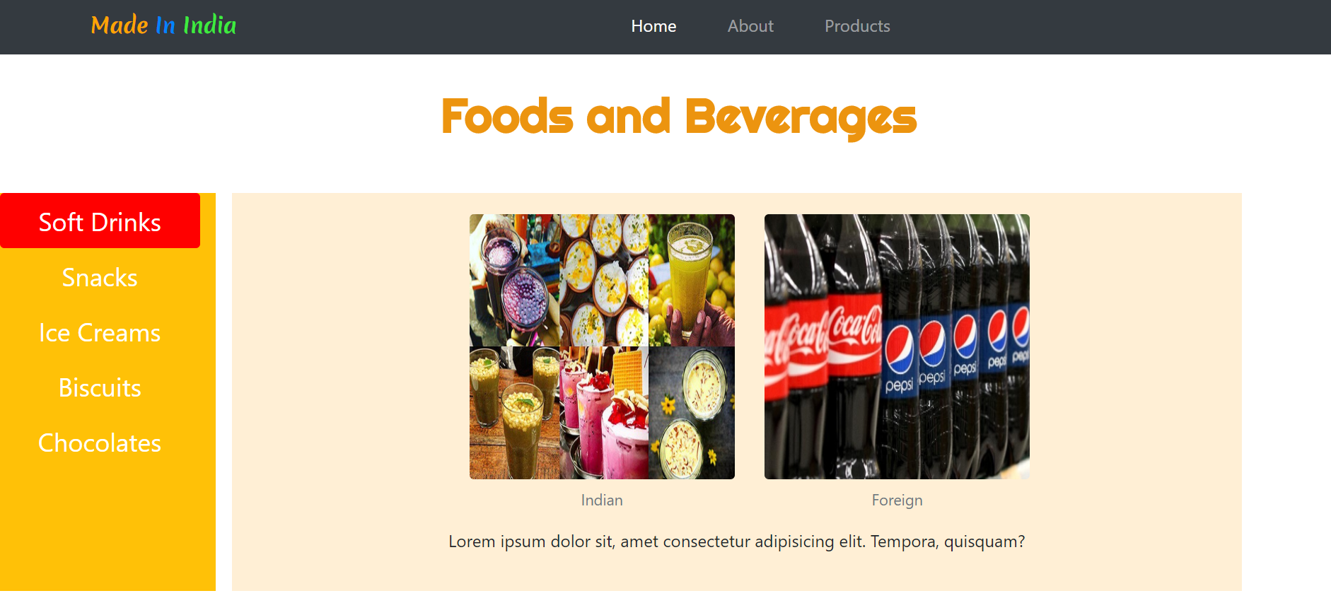

**Image Credits:**

Soft drinks - <https://medium.com/@Indian_encyclopedia/indian-beverages-indian-food-cefca2fbd216>

Snacks - <https://www.indiaretailing.com/2019/04/26/food/food-grocery/india-a-growing-market-for-new-flavors-of-snacks/>

foreign soft-drinks - <https://www.behindwoods.com/news-shots/merchants-are-considering-the-boycott-of-foreign-drinks-vikrama-raja.html>

indian-biscuits - <https://www.flickr.com/photos/301202/2112649307>

foreign-snacks - <https://www.amazon.com/Snack-Box-around-world-Package/dp/B01H0X02J8>

indian- chocolate - <https://www.facebook.com/amul.coop/posts/this-extra-dark-chocolate-is-not-for-the-faint-hearted-intense-and-luscious-this/10156995919914446/>

**Things to be done next:**

* Make the electronics and Mobile Applications page.
* Add the information about which foreign product is substituted by Indian Product.